Task 6.3

Isaac Pittolo – 7695438  
Hoang Linh Bui – 100017631  
Adam Bubonya – 9986677

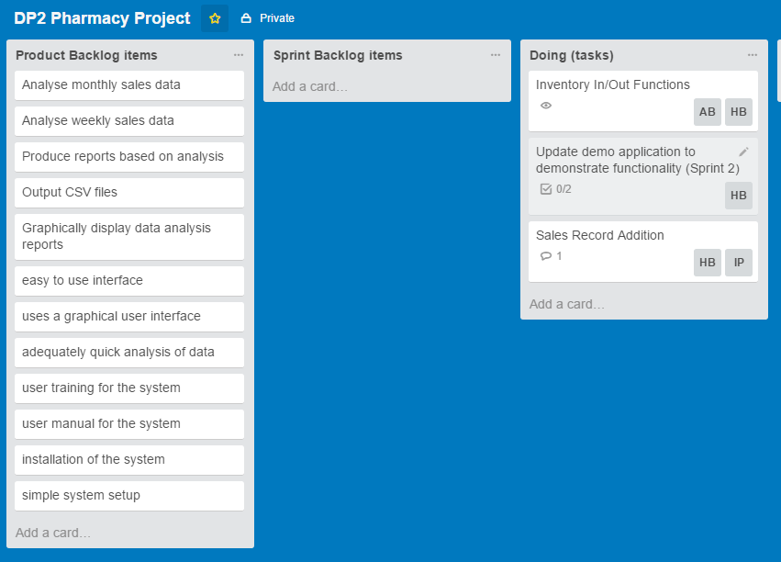

Figure 1 – Our Sprint 2 Tasks

Our team discussed our issues in the last sprint and have decided that we will be attempting the same items as we did in the last sprint, as they were not nearly functional enough to be considered for testing, let alone accepted into a working application.

Ultimately this will put us considerably far behind on our deadline but it is necessary as core functionality could not be completed in the last sprint. These features our biggest dependencies and we need them to maintain a functional application. They need to be completed first as everything else is related to these few functions.

Additionally we would like to get something that can be demonstrated to the end user. Therefore, Hoang decided he would also attempt to make the application work well for the average user.

Our justification for all this is that we did not have a working product from the last sprint and there is no point overwhelming ourselves with work we cannot possibly finish by merging our original Sprint 1 and Sprint 2.

The features we discussed originally are also considerably bigger than any of us could expect. We heavily underestimated how much work we had given us and overestimated our abilities as a team. So by repeating this sprint we should be able to make up for our very slow velocity that we demonstrated in the previous sprint.

To conclude 6.2, the below is our Burndown for Trello that shows our projected workflow as well as our current progress. We aim to put in a lot of work into our delegated features and so we have set our hours accordingly.

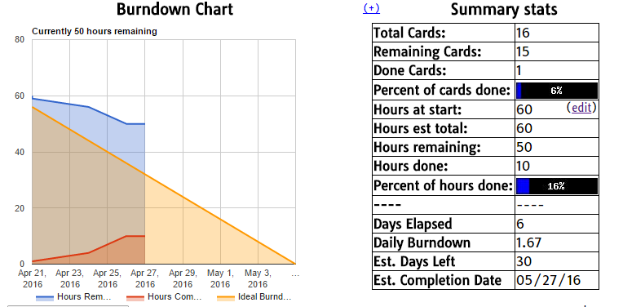

Figure 1 – Burndown Chart with summary of statistics as of 28th April

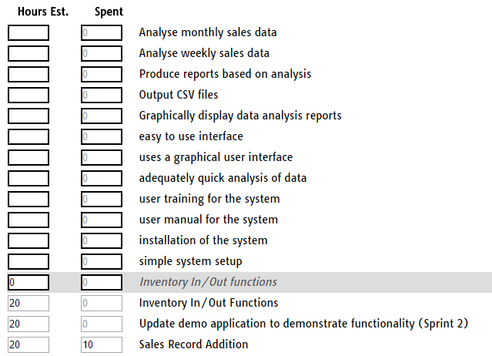

Figure 2 – Hours estimated and currently worked